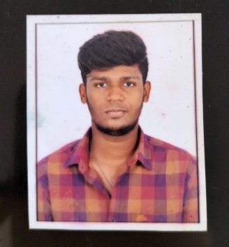

Moneesh P

# SKILLS

* Python
* HTML, CSS
* C Language

# LANGUAGES

* English
* Tamil
* Telugu

# CONTACT INFORMATION

**Address:** 101 Marvel river view county manapakam chennai-600125

**Phone**:

+91 8825881496

**Email:**

Moneesh.p2001@gmail.com

## OBJECTIVES

An enthusiastic student with good leadership and communication skills seeking good role in your reputable organization which will enhance my skills and contribute in the growth of the organization.

### EDUCATION

2017

Bethel Matric Hr school

* 10th
* 97%

2019

SKV Hr. Sec School

* 12th
* 67.7%

2019 - 2023

Saveetha Engineering College

* B.Tech (computer science and engineering)
* 8.5 CGPA

### PROJECTS

* **Mini Project**

Auto Text complete system next word predictor:

As natural language processing is improving faster day by day there are manynew application in it.

### 

### PERSONAL DETAILS

* Date of Birth: 20/08/2001
* Age : 21
* Gender : Male
* Nationality : Indian

### INTEREST:

* Travelling
* Music
* Cycling

### DECLARATION

* I hereby declare that all the details stated above are true and correct to the best of my knowledge